### .3.6 PERSISTENT DATA MANAGEMENT

The purpose of this section is to show the mapping of the objects/classes of the system, identified  
during the analysis stage, in to the corresponding relational database.

Diagram 4bellows are mapped in (form):

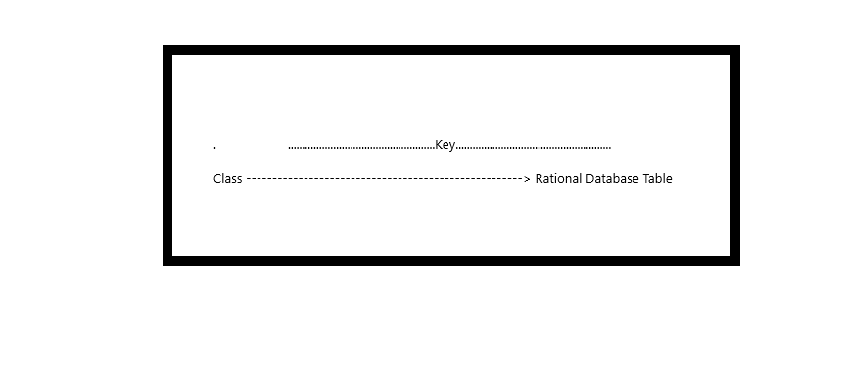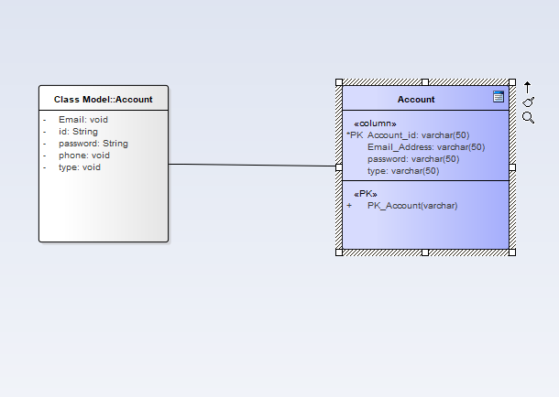

Figure- Object account mapping

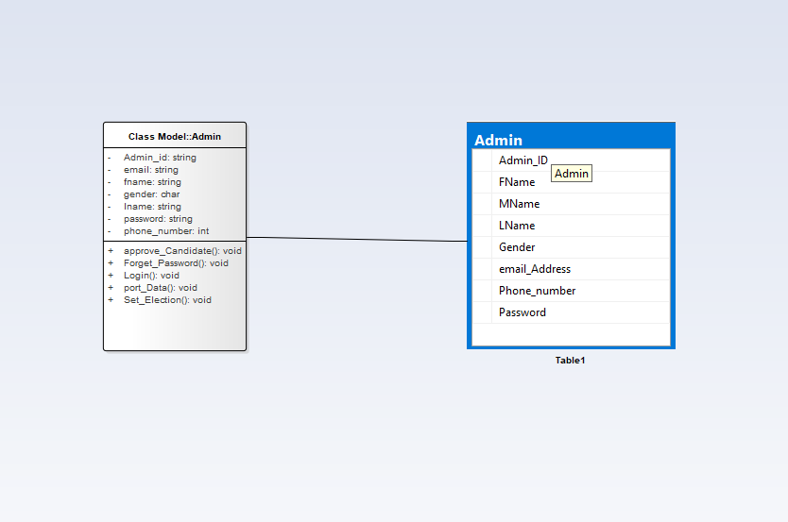

Figure -object admin mapping

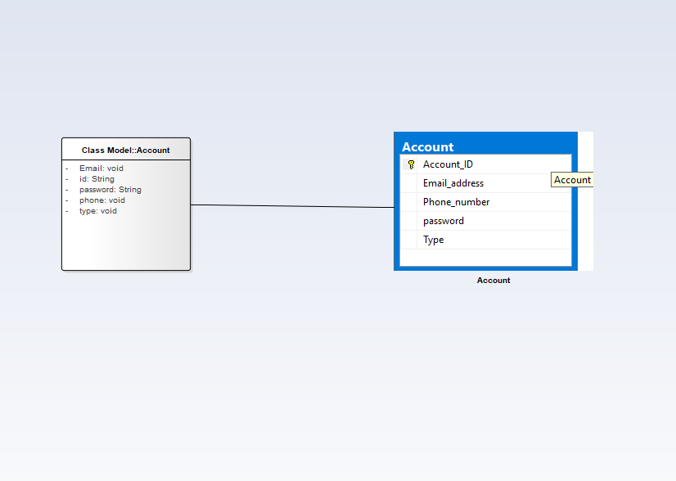

Figure- object account mapping

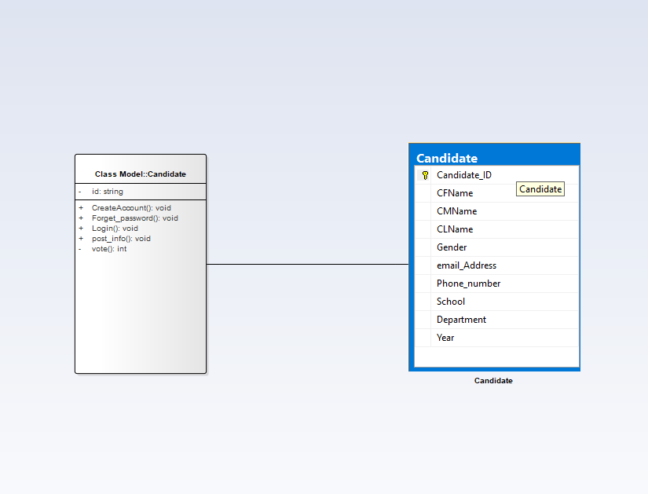

Figure-object candidate mapping

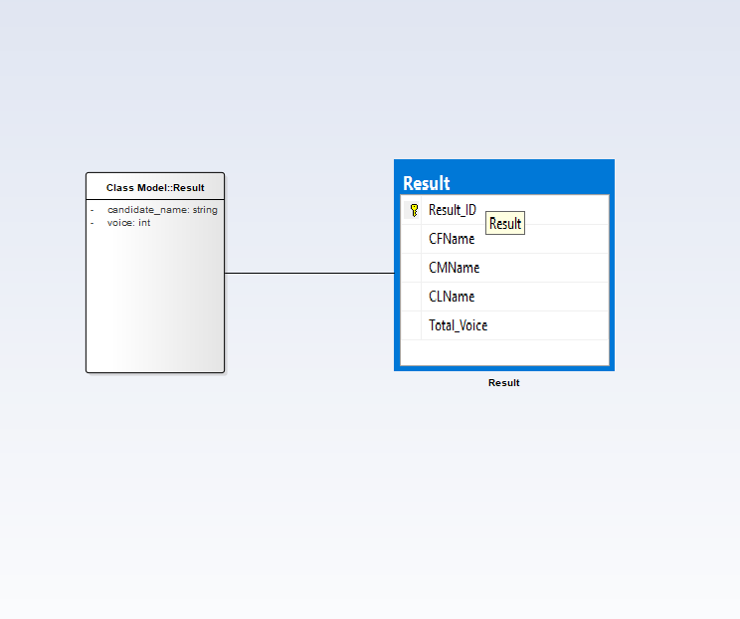

Figure-object result mapping

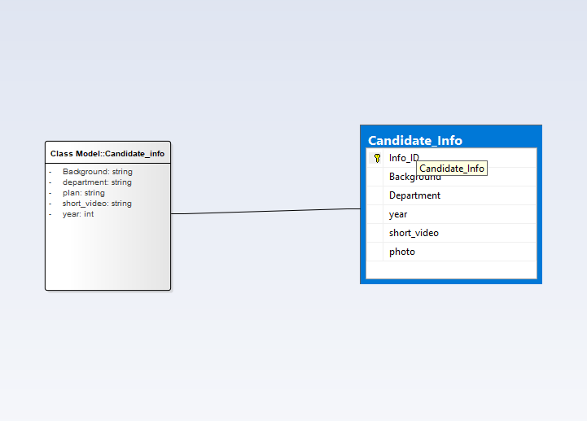

Figure-object candidate_info mapping

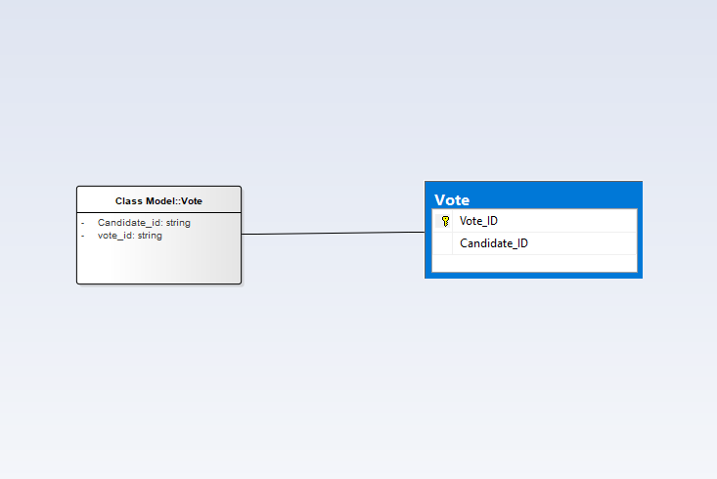

Figure-object vote mapping

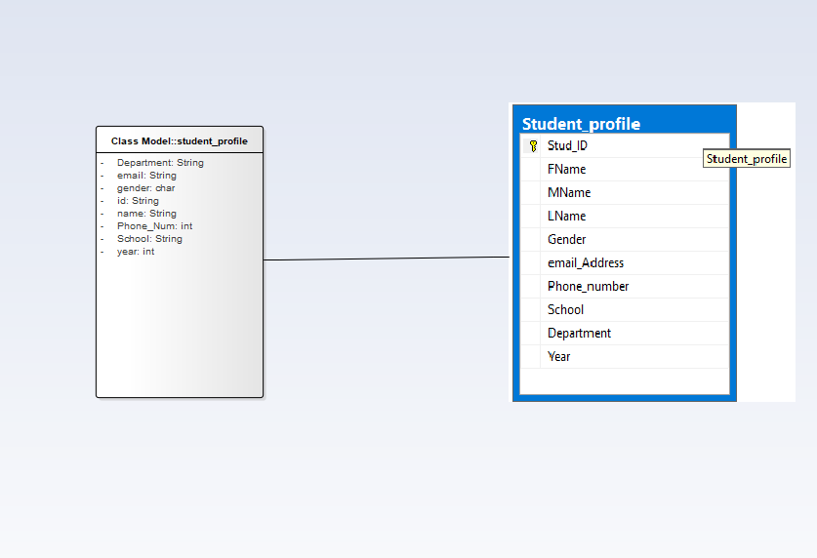

Figure-object student_profile mapping

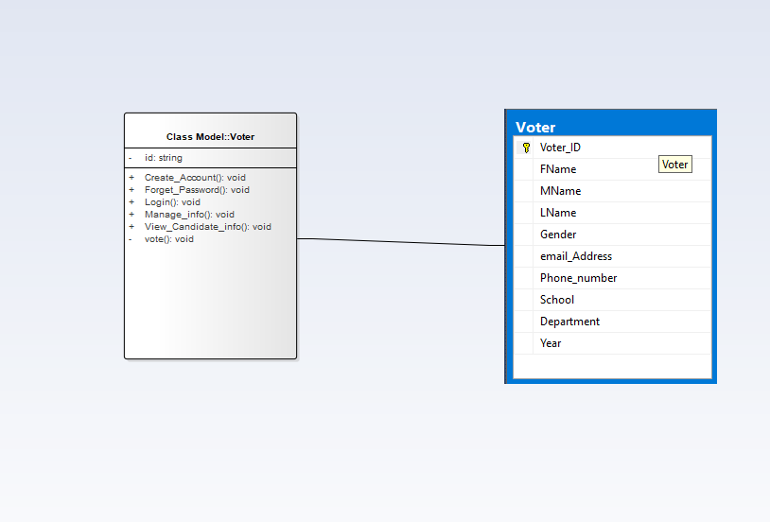

Figure-object voter mapping